HandsOn 1:

**Creating Microservices for account and loan:**  
**Account Microservice:**

AccountController.java

package com.cognizant.account.controller;

import org.springframework.web.bind.annotation.*;

import java.util.HashMap;

import java.util.Map;

*@RestController*

*@RequestMapping*("/accounts")

public class AccountController {

*@GetMapping*("/{number}")

public Map<String, Object> getAccount(*@PathVariable* String number) {

Map<String, Object> response = new HashMap<>();

response.put("number", number);

response.put("type", "savings");

response.put("balance", 234343);

return response;

}

}

**Output:**  
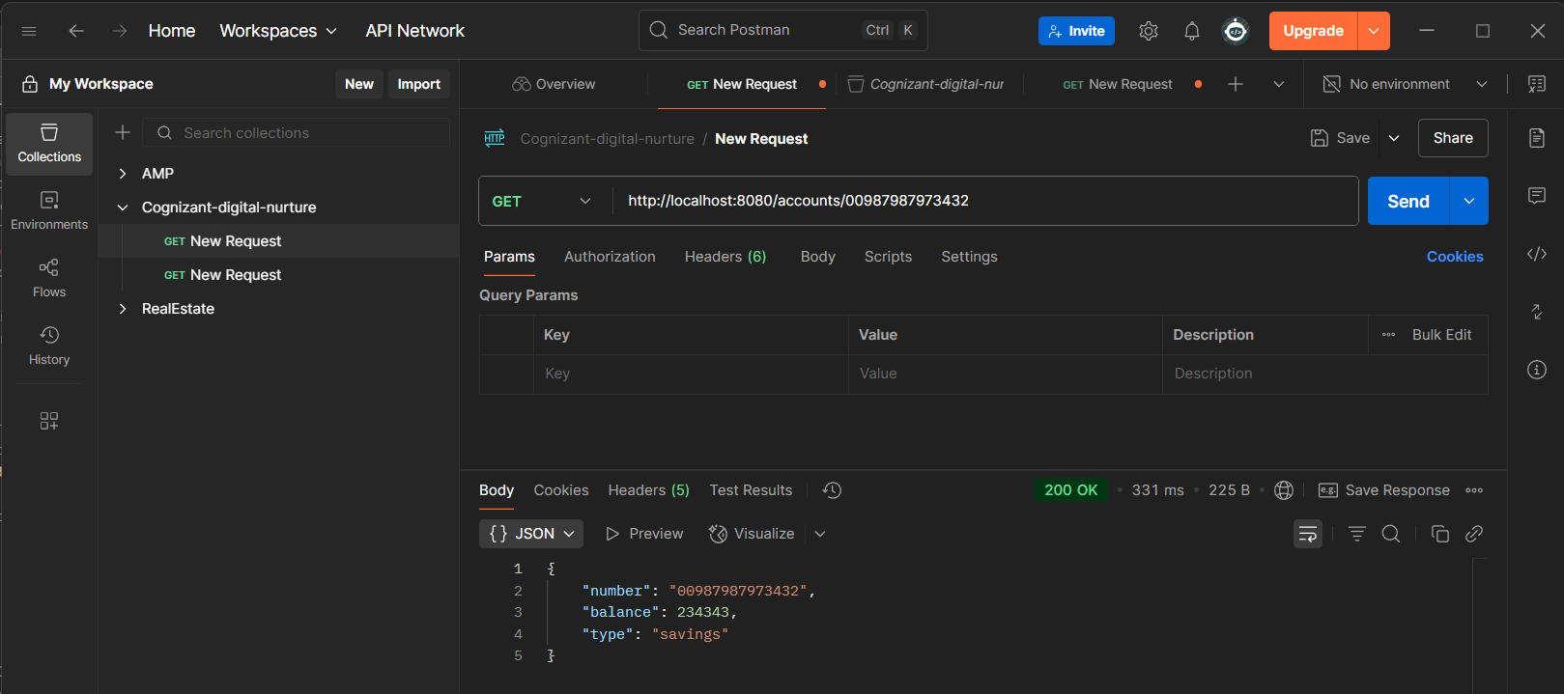

**Loan Microservice:**

**LoanController.java:**

package com.cognizant.loan.controller;

import org.springframework.web.bind.annotation.*;

import java.util.HashMap;

import java.util.Map;

*@RestController*

*@RequestMapping*("/loans")

public class LoanController {

*@GetMapping*("/{number}")

public Map<String, Object> getLoan(*@PathVariable* String number) {

Map<String, Object> response = new HashMap<>();

response.put("number", number);

response.put("type", "car");

response.put("loan", 400000);

response.put("emi", 3258);

response.put("tenure", 18);

return response;

}

}

**Output:**  
